1. **Task Description:-**

The task was to build a personal portfolio web application using **React.js** that showcases projects, skills, education, certifications, and contact details.

1. **Task Output Screenshots:-**
   1. Home:-

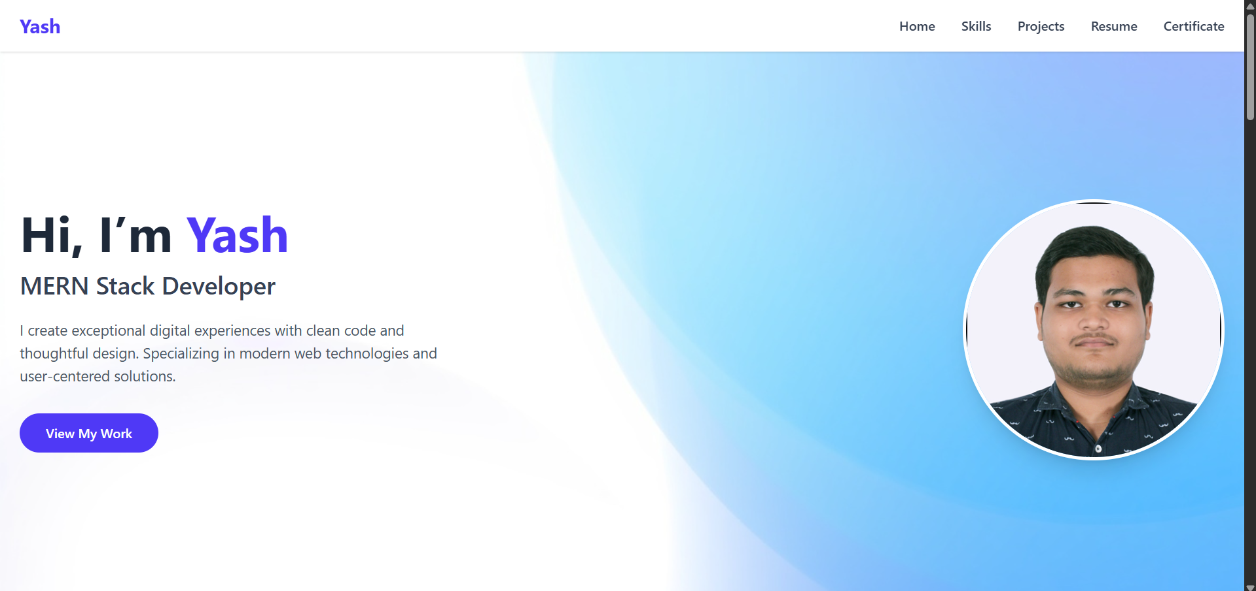

* 1. Skills:-

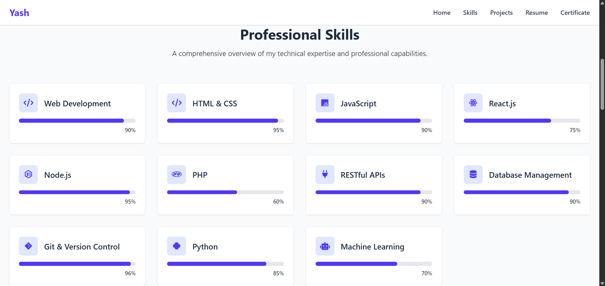

* 1. Projects:-

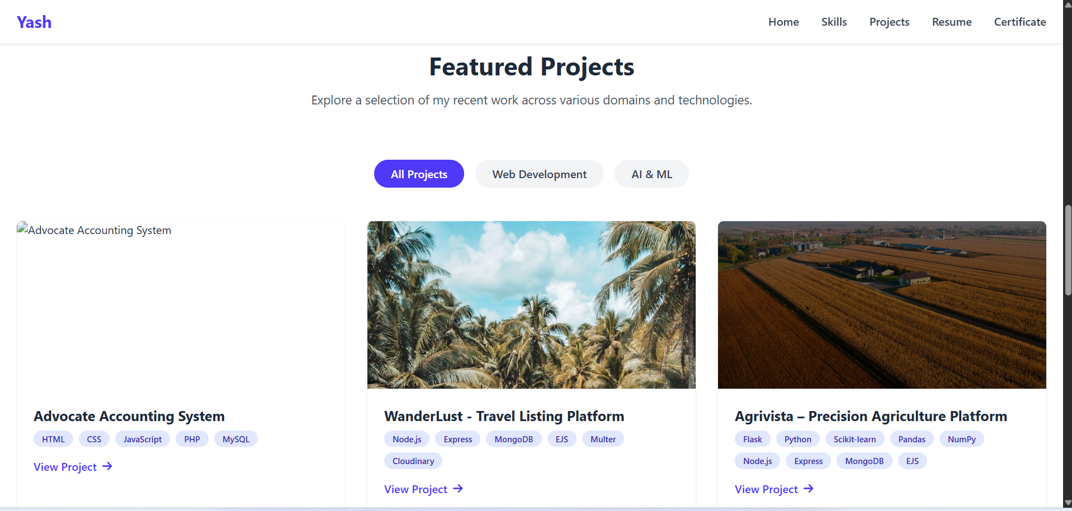

* 1. Professional Journey:-

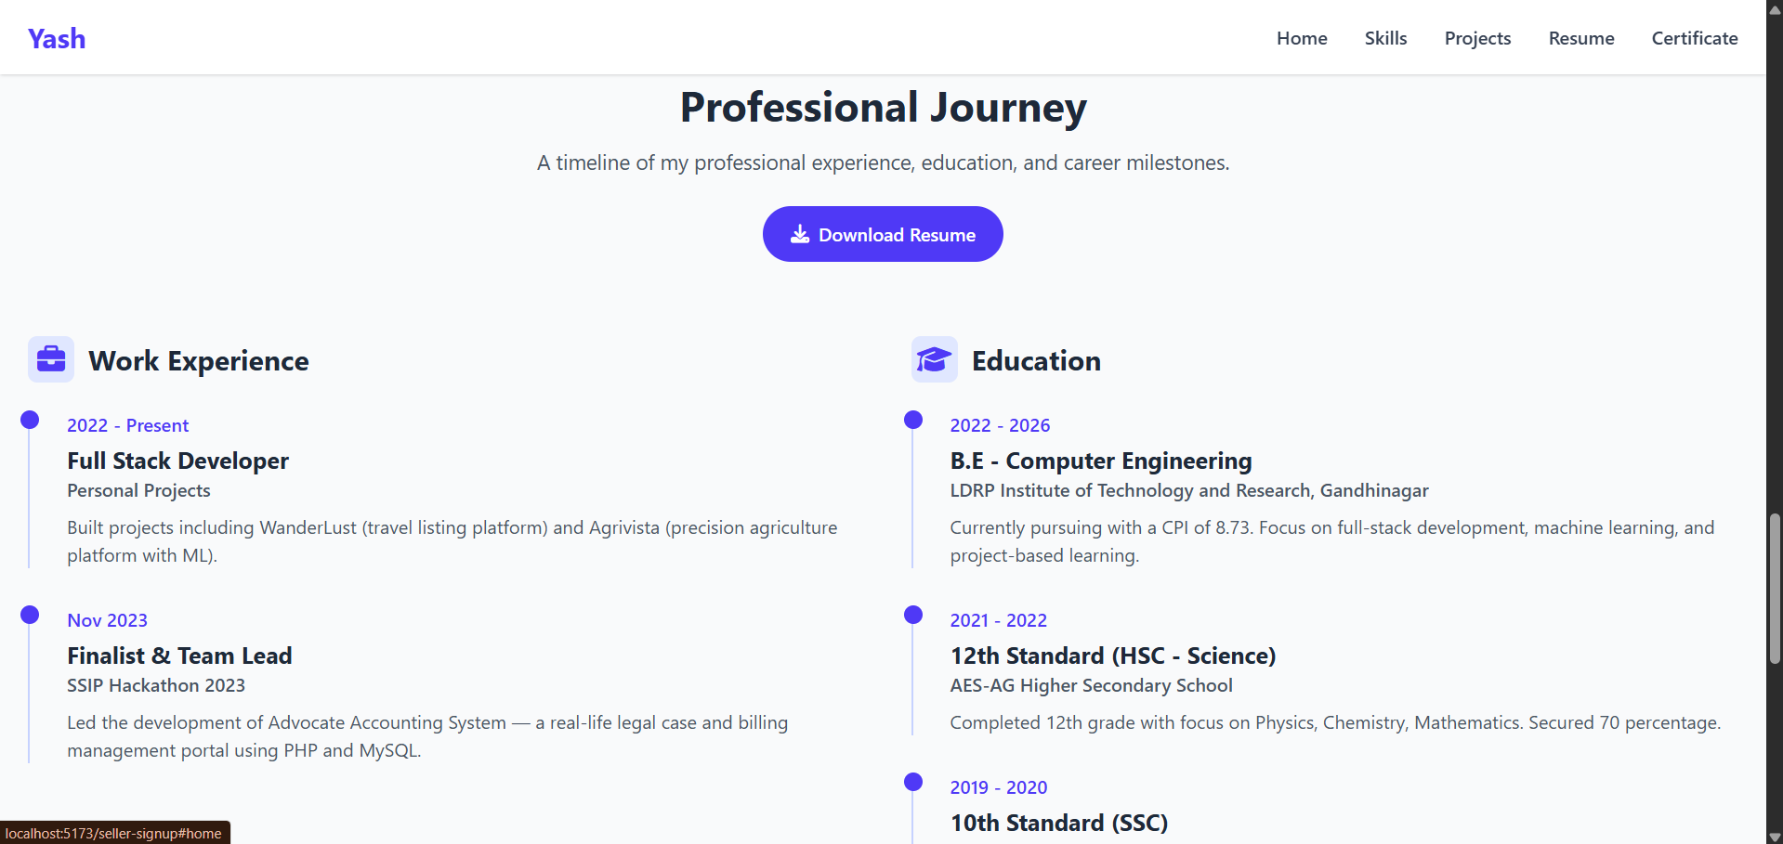

* 1. Certificates:-

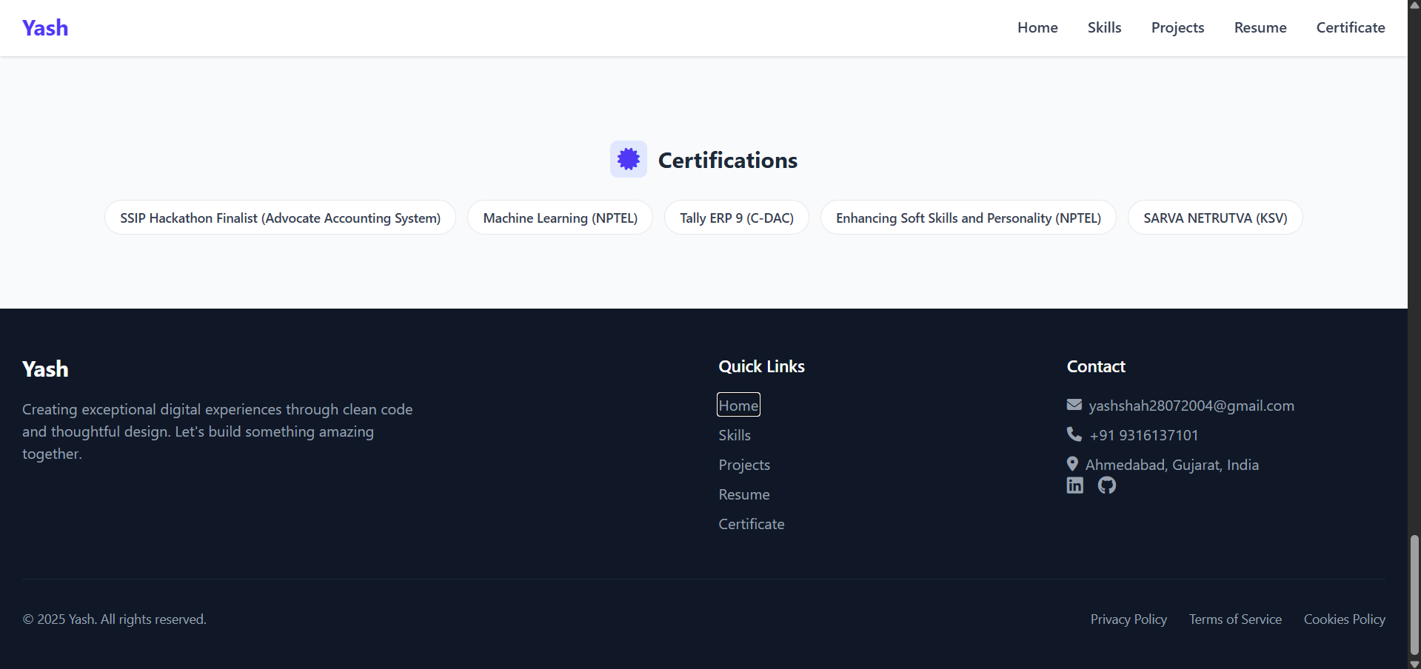

1. **Widget/Algorithm Used in Task:-**
   1. **Font Awesome :** Used for adding icons to represent technologies, social links, and certifications**.**
   2. **Tailwind CSS:** Used for fast and clean utility-first styling, ensuring responsiveness and consistency across all sections.
   3. **Dynamic Data Mapping:** All projects, skills, education, and certifications are mapped dynamically from arrays, allowing easy updates without altering the JSX structure.
   4. **Responsive Grid / Flex Layouts:** Implemented to ensure that the portfolio looks good on both mobile and desktop devices.